**ASSIGNMENT – 5**

1. Define photo shop. What are it uses?

Ans: Photoshop is an image creation, graphic design and photo editing software developed by Adobe.

Uses:

1. Photo Editing
2. Web designing
3. Logo designing
4. Product photo
5. Digital Art
6. GIF Animations
7. Print Images
8. Social media images
9. To remove background fro photo
10. Web Ads.
11. Define channel. Explain the different channel used in Photoshop. Discuss the process of creating Alpha Channel.

Ans: Channels can be confusing. But it gets a lot simpler if you understand the science behind it.

Channels are used for a variety of purposes in Photoshop. The most common use for channels is to create masks.

A channel can be used as a mask to isolate an area of an image for editing. Channels can also be used to create selections. By creating a selection in a channel, you can make changes to that area without affecting the rest of the image.

Channels can also be used to adjust the levels of an image. By adjusting the levels in a channel, you can make changes to the brightness and contrast of an image.

Channels can also be used to color correct an image. By Adjusting the colors in a channel, you can change the overall color of an image.

Channels are also used for a variety of other purposes such as creating depth maps, modifying shading, and even creating 3D images.

**Channels are a versatile tool that can be used for a variety of purposes in Photoshop.**

Creating an alpha channel in Photoshop is a fairly easy task. Yet, it creates several new editing opportunities, giving you the ability to take your editing skills to the next level.

In this example you can isolate an object from the background in an alpha channel, this will let you easily use the object on other backgrounds for multiple projects.

**Creating An Alpha Channel**

To create a completely new alpha channel, navigate to the**Channels** panel located next to your layers. If you cannot see this option select **Window > Channels**and it will appear. 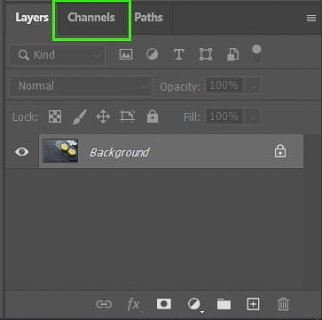

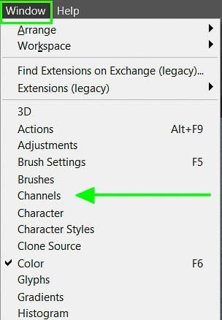

Click on the drop-down menu at the top right of the **Channels** panel and select **New Channel.**Choose a name for the channel on the pop-up window.

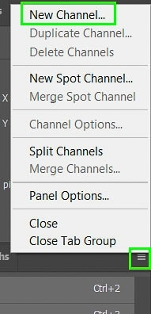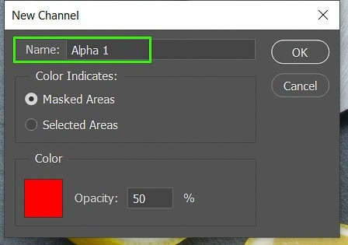

You can then use the brush tool by selecting the brush tool from your toolbar or **press B** on your keyboard. This enables you to draw areas that you would like to select by detracting from the alpha channel.

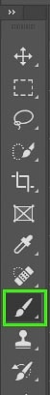

You can then create a selection from your marks by selecting **“Save selection as channel”** at the bottom of the **Channels** panel. From there, you can edit the selected area as needed by choosing any of the Adjustment tools.

You will see the alpha channel shows as a[red overlay](https://www.bwillcreative.com/why-is-my-layer-red-in-photoshop/)at 50% opacity. When you use the**Brush** tool it removes parts of the overlay to show where your selection is.

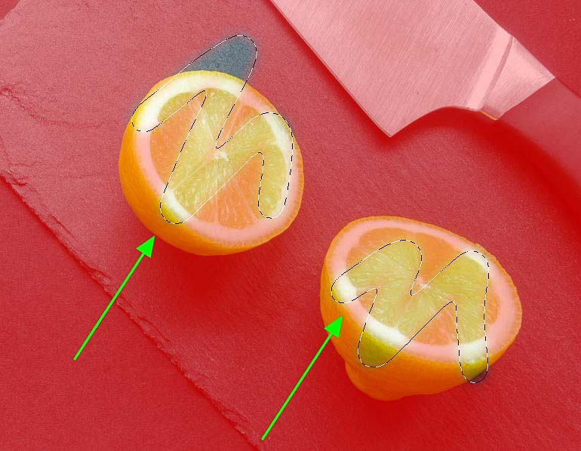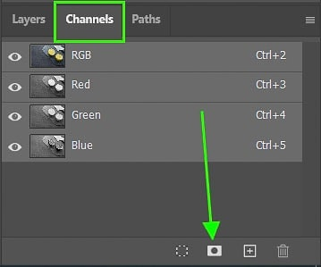

**Creating An Alpha Channel From A Selection**

To create the selection first then make an alpha channel, start by [selecting your object](https://www.bwillcreative.com/how-to-use-the-object-selection-tool-in-photoshop/). This can be done using any selection tool. For this example, I’ll use the [**Quick Selection** tool](https://www.bwillcreative.com/how-to-cut-out-an-image-in-photoshop/) by pressing **press W** on the keyboard.

If you want to choose a different selection tool, hold down on the **Quick Selection** icon until an additional menu pops up.

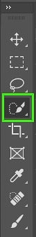

Next, select the object you want to isolate by creating your selection. You will see your selection by the dotted lines.

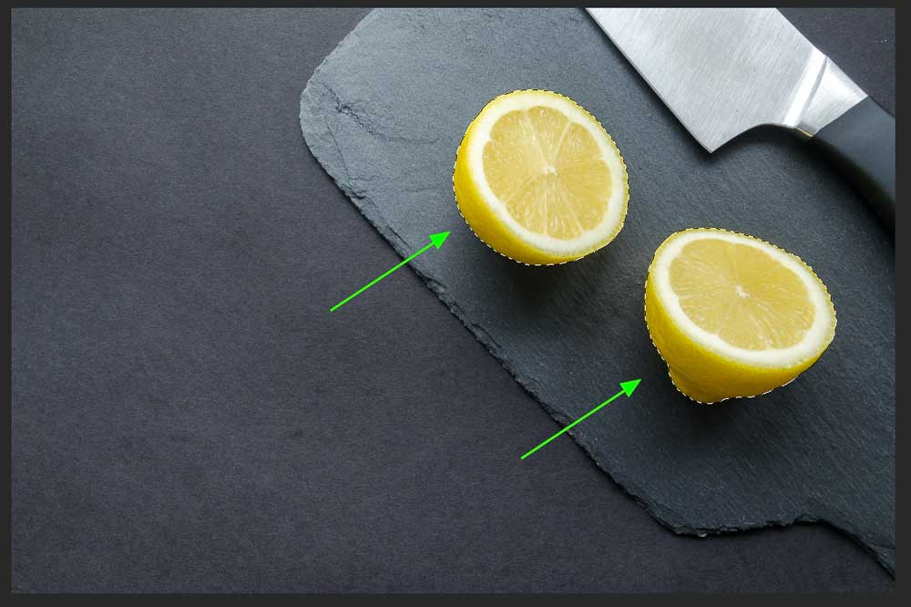

You can then refine your selection if needed by clicking the**“Select and Mask”** option on the top options bar. This allows you to smooth the edges or feather your selection. However, once the alpha channel is created we can refine this even more.



**Saving Your Selection: Method 1**

There are two ways to create the alpha channel. The first one is by right-clicking on your image and clicking **“Save Selection”.** A window will open where you will be able to name your new channel.

This method is helpful if you would like to save the alpha channel in a different document as long as the pixels are the same between both documents.

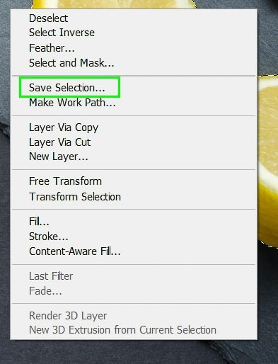

This method is also useful if you would like to add a new selection to an alpha channel that you have already created. To do this select the dropdown menu next to **“Channel”** when the window pops up, select the channel, and choose the **“Add to Channel”** option in the bottom section.

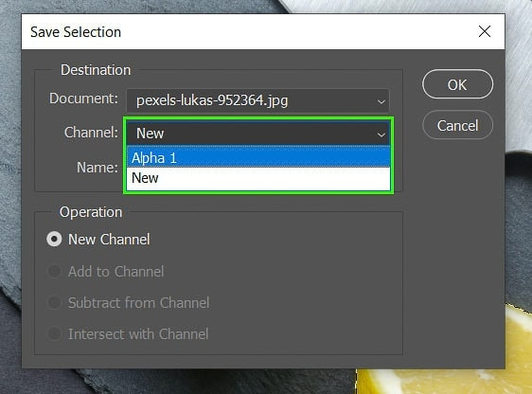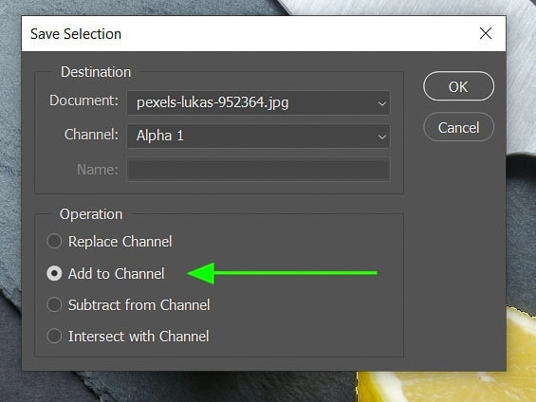

**Saving Your Selection: Method 2**

The other method to add your channel is to navigate to your**Channels** panel on the right-hand side of your workspace. This option is right next to the layer panel. At the bottom, click on **“Save selection as channel”.**

This will automatically create an alpha channel based on your selection. Click **Control + D**(Windows),**Command + D**(Mac) to [deselect the object](https://www.bwillcreative.com/how-to-deselect-in-photoshop/) as the selection is now saved.



**Editing Your Alpha Channel**

If you want to refine your selection even more you can edit your alpha channel to create a more precise selection.

Start by making sure your **Alpha Channel**is selected by toggling the eye icon next to the channel. You can turn the other channels off to only see your alpha channel in the workspace.

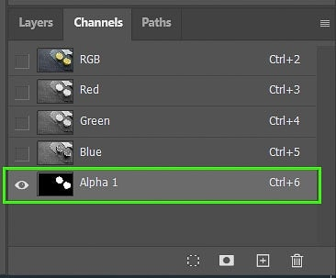

Now, **press B** on your keyboard to select the brush tool. Using the white and black colors you can either add or subtract from your selection.

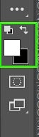

**Remember**

* White: Will add to the selection and this is the area you can edit.
* Black: Detracts from the selection and is the area protected from editing.

You can also change the opacity on the top options bar when adding or subtracting parts of your selection.



Once you have your new alpha channel you can create a selection from it at a later stage, use it as a layer mask to edit specific areas, or use it in other programs that support it. Simply click on **“Load channel as a selection”** at the bottom of the **Channels** panel to load it.

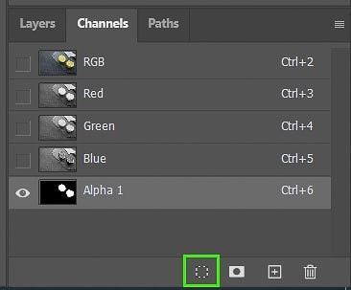

It is important to note that alpha channels will only be saved in [PSD](https://www.bwillcreative.com/psd-vs-psb-photoshop-files/), PDF, TIFF, or PSB. Other formats such as [JPEG](https://www.bwillcreative.com/what-are-jpeg-photos/) and [PNG](https://www.bwillcreative.com/how-to-edit-a-png-file-in-photoshop/)do not save the alpha channel data as they are compressed versions of the file.

**How To Create Alpha Channels From Transparency**

If you have an image that already contains a transparent background you can create an alpha channel using two methods.

Create a selection by clicking on the layer that contains the object in the layers panel while holding in **Control** (windows), **Command**(Mac). This selects the entire object.

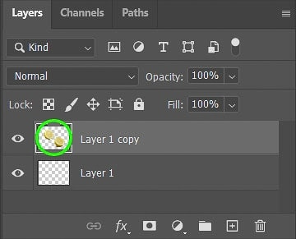

Then navigate to the**Channels** panel and choose the **“Save selection as channel”** option at the bottom. This will create your alpha channel which you can then transfer to other programs or edit as needed.

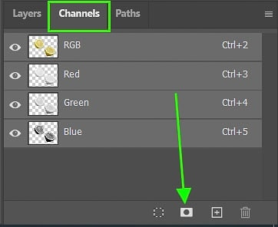

The second method is done by first making sure you have selected the desired layer you wish to create an alpha channel from.

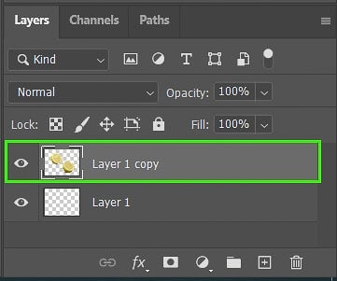

Then navigate to **Layer > Layer Mask > From Transparency.** This will automatically [create a mask](https://www.bwillcreative.com/how-to-use-layer-masks-in-photoshop/) on your layer containing the non-transparent elements. It will also appear in the **Channels** panel as a separate channel.

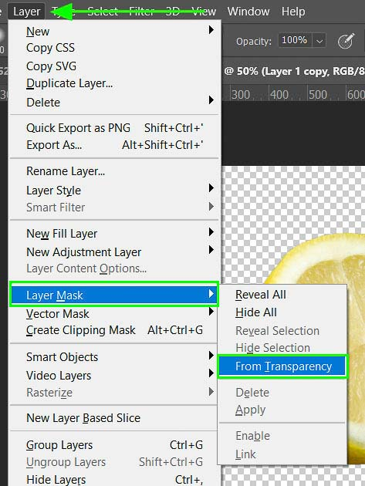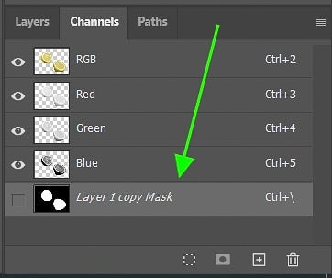

You can then **“Load channel as a selection”** at the bottom of the **Channels** panel and **“Save selection as channel”**to create a separate alpha channel if you decide to delete the layer mask.

1. What are the different tools used in Photoshop?

## Ans:The Toolbar

The Photoshop Toolbar can be configured depending on how you do your work. You can display the tools in one long pane, or as we prefer: **display the Toolbar as a double panel.**

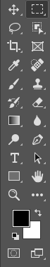

And if that were not enough, you can drag the Toolbar and have it “float” anywhere on your “canvas”.

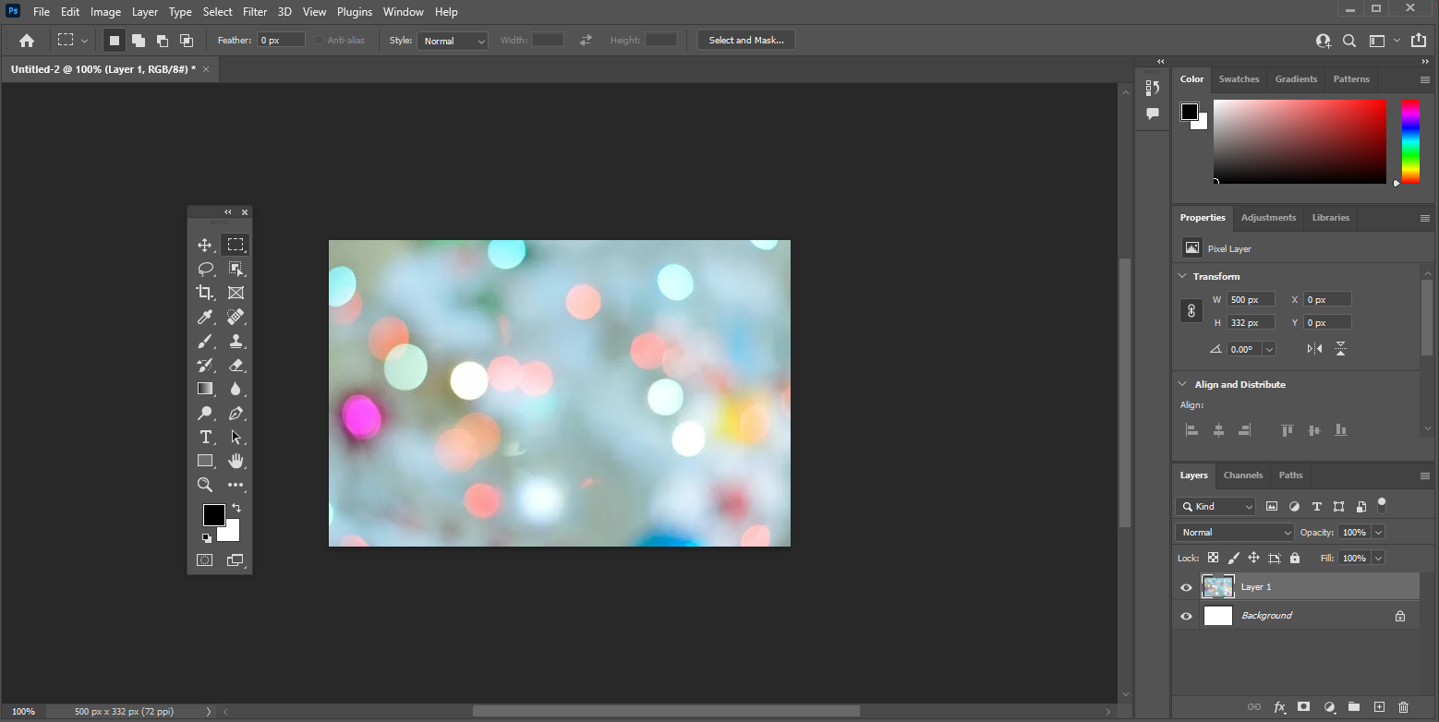

Photoshop has many useful keyboard shortcuts. In this case, instead of right-clicking on the tool, you can press “W” and then “Shift-W” to toggle between two tools.

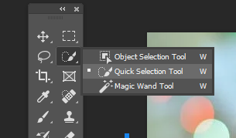

When you select a tool, a video displays next to the tool to show how it works. It’s a good way to let you know that you have the desired tool.

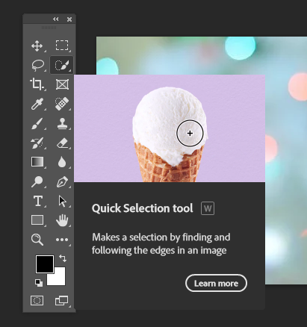

From the **Edit** menu, you can select the **Tools…** option. The **Customize Toolbar** window lets you customize the toolbar to fit the way you do your work.

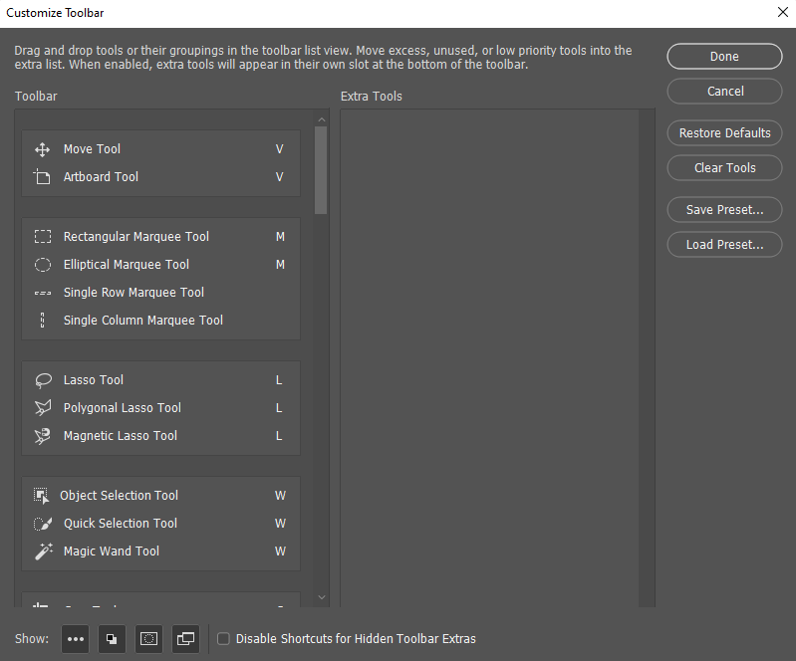

These are the most commonly used Photoshop tools:

* Move Tool
* Marquee Tools
* Lasso Tools
* Quick Selection Tool/Magic Wand Tool
* Crop Tool
* Eyedropper Tool
* Spot Healing Brush/Healing Brush/Patch Tool/Content-Aware Move Tool/Red Eye Tool
* Clone Stamp Tool
* History Brush Tool
* Eraser Tool/Background Eraser Tool/Magic Eraser Tool
* Zoom Tool

**The Move Tool**

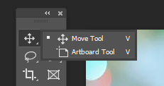

The Move Tool is used to move part of a layered image to a new location.

You need to be aware that this tool only works when there is something to move inside the image. In other words, **you need at least two layers to use the Move Tool**.

Or a single layer that is not locked.

In the image below, the image is in its own layer.

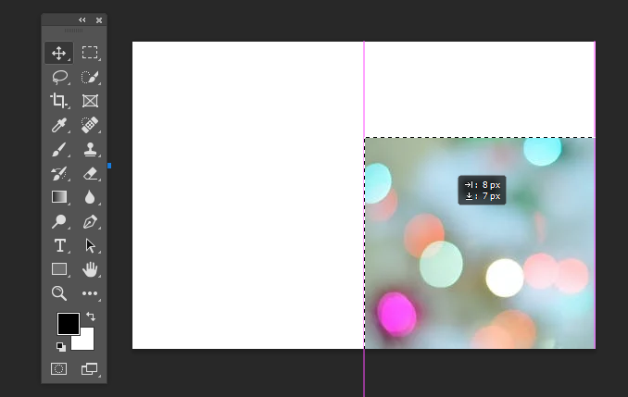

Select it and select the Move Tool and drag the object to another location in the image.

**The Marquee Tools**

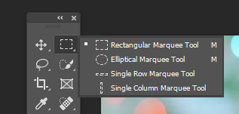

There are several marquee tools that you can use to select a part of an image.

**NOTE: Hold the SHIFT key to add to the selected area, and hold the Option/Alt to subtract from the selected area.**

As you might expect, the Rectangular Tool makes a rectangular selection, and the Elliptical Tool makes a round selection.

Here is an example of using the Rectangular Tool:

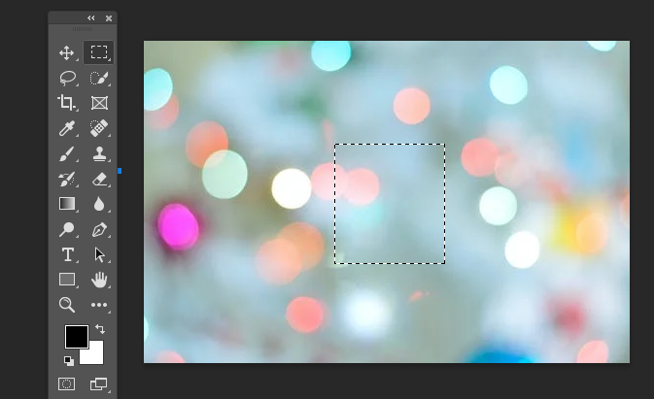

**The Lasso Tools**

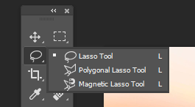

You can also make selections using the lasso tools. The Lasso Tool lets you make a selection around anything on a layer just like you would if using a real lasso.

The Polygonal Lasso Tool also lets you select an area, **but only by making straight lines.**

The Magnetic Lasso Tool allows you to select an object by trying to find the edge of the object **and assigning anchor points like you are using a magnet to attract the points.**

Here is an example of using the Lasso Tool:

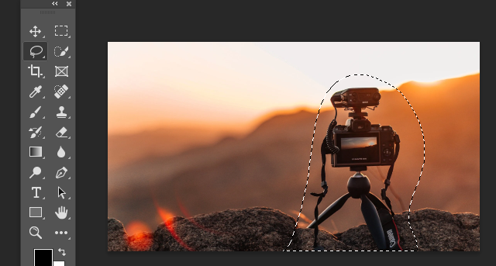

**The Quick Selection Tool/Magic Wand Tool**



The Quick Selection Tool allows you to select objects by concentrating on the edges. Just drag the tool over the object to select it. **The Magic Wand Tool makes a selection based on the part of the object where you click your mouse.**

Here is an example of the Magic Wand Tool identifying the background of a given image:

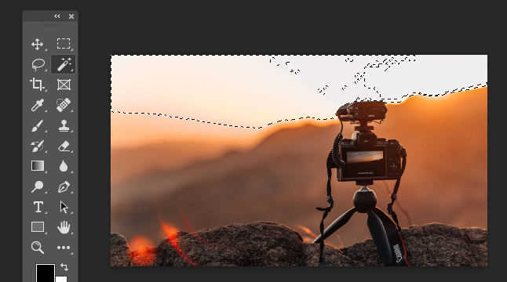

**The Crop Tool**

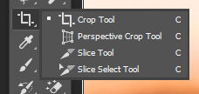

The Crop Tool allows you to crop an image **just by dragging the markers on the image borde**r.

Here is an example of the Crop Tool:

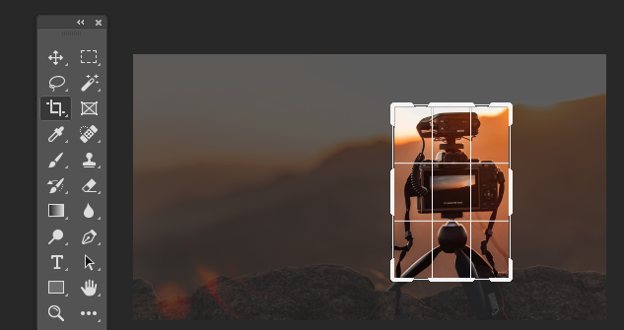

**The Eyedropper Tool**

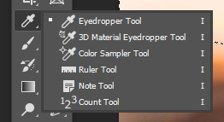

The Eyedropper Tool lets you click on a colour in the image in order to use it in other areas of an image or in another image entirely. **The Color Sampler Tool allows you to sample up to four different colours in an image.**

The most recent versions of Photoshop even include a handy indicator for what color is above and below so you can clearly identify the position it is pulling your color from.

Here is an example of the Color Sampler Tool. The selected area can be seen on the basketball:

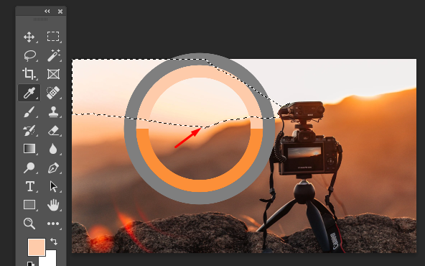

**The Spot Healing Brush/Healing Brush/Patch Tool/Content-Aware Move Tool/Red Eye Tool**

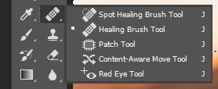

The Spot Healing Brush lets you remove imperfections. It looks at the area around where you click the mouse in order to blend the imperfection into the image.

The Healing Brush Tool also lets you eliminate imperfections in an image. **You have to select a point on the image, unlike the Spot Healing brush.**

The Patch Tool lets you make a selection as the Lasso Tool does. You can drag the selection to the area in order to fill it with the selection.

The Content-Aware Move Tool looks at any content selected to be moved and tries to fill in the area from which the selected content has been moved. For example, if you move a window from a house in an image, Photoshop will try to fill in the empty area with content from the rest of the house, **as if the window had never been there.**

**The Red Eye Tool is a way to quickly remove areas that have red eye from improper flash lighting.**

Before and after example of the Spot Healing Tool, notice how the lens flare inside the rock has faded significantly:

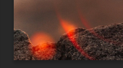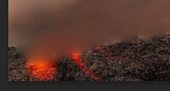

**The Brush Tool**

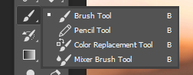

The Brush Tool is a very important tool; you’ll probably use the Brush Tool the most if you are retouching images. The Pencil Tool lets you draw on an image as if you were using a real pencil. The Brush Tool using the colour selected by the Eyedropper Tool. In the example below, a yellow panel of the balloon was selected and used as a brush.

**As you can see, you could easily change the entire background to fit a suitable color to the rest of the image.**

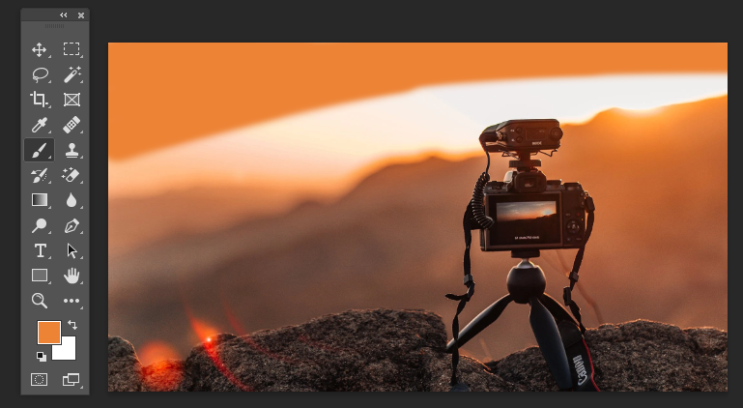

**The Clone Stamp Tool**

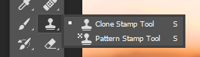

The Clone Stamp Tool is used to clone or copy image information from one area to another. You can hold the Option/Alt key and click an area of an image. Then, click the image to brush with the color and image information that you sampled.

Before and after example of the Clone Stamp Tool, notice how the rock has grown significantly:

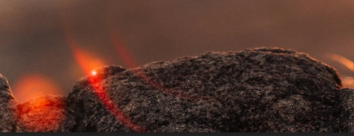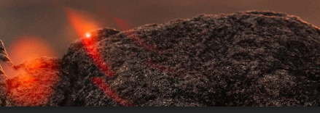

**The History Brush Tool**

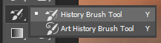

This tool is like an Undo feature. You can use it to step back until you return to the desired change.

Here is an example of using the History Brush Tool from the previous tool, the rock has been returned to its original shape on the left but stayed large on the right. This is due to it being History Brushed away on the left only.

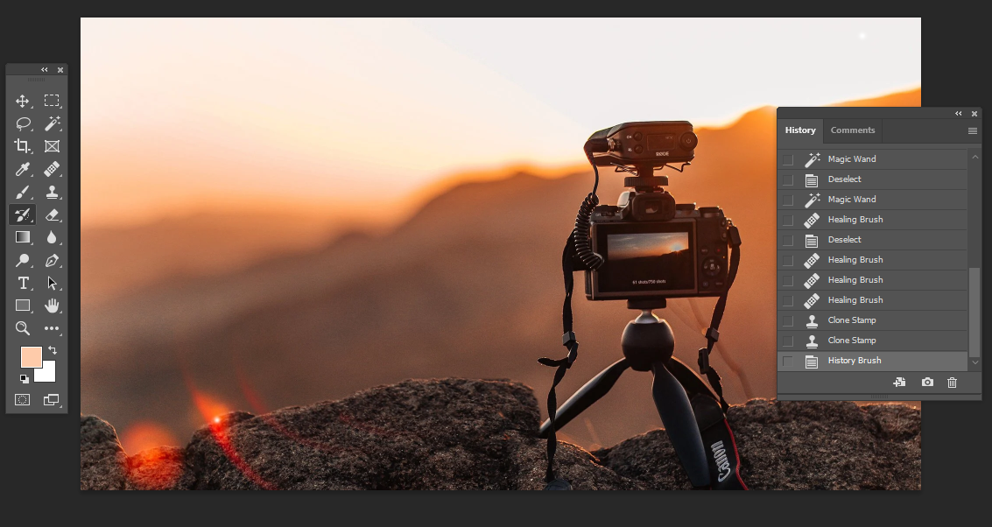

**The Eraser Tool/Background Eraser Tool/Magic Eraser Tool**

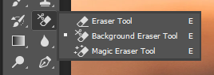

The Eraser Tool removes undesired detail just like a real eraser.

The Background Eraser Tool lets you remove the background from an image. Drag the eraser along the edges of an image and its background in order for it to remove the background.

The Magic Eraser Tool can remove part of the background of an image depending on the area you select.

Before and after example of the Eraser Tool:

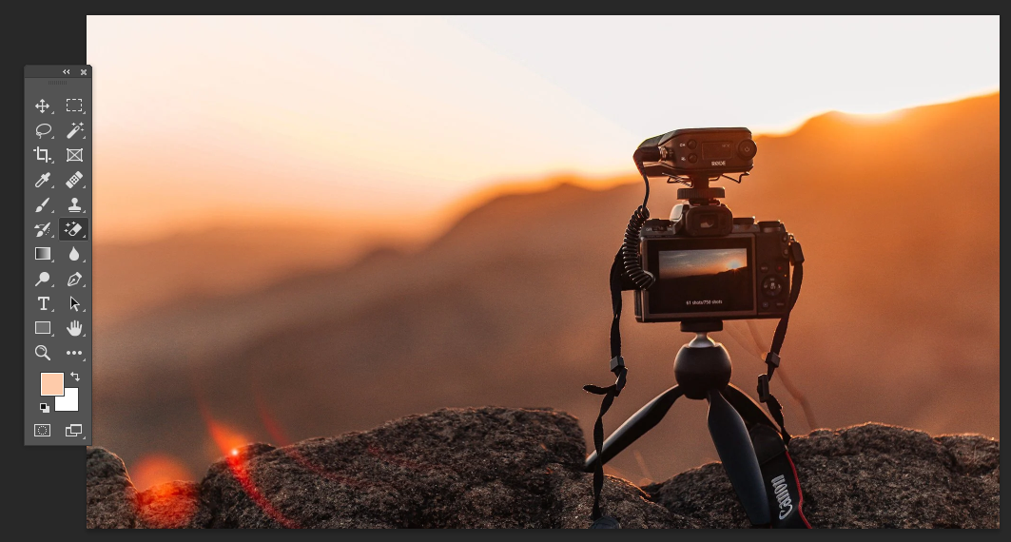

The sky in the background has been erased.

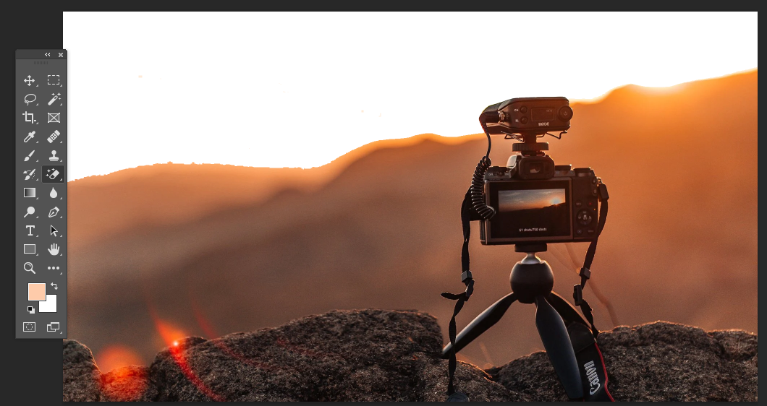

**The Zoom Tool**

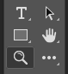

The Zoom Tool is used to magnify a portion of your image when you are doing detailed work. Click and drag a selection of an image and Photoshop will zoom in on that area.

Example of the camera image being zoomed in on.

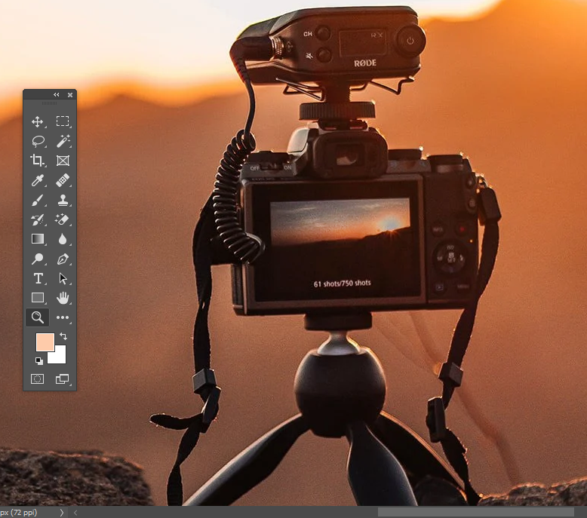

1. Explain the features and importance of using layers.

Ans: At this point, you may be wondering why you even need to use layers. Wouldn't it just be easier to work with everything in your image at once? The truth is, layers give you an amazing amount of flexibility and control because you can **edit each layer independently** from the rest of the image. Once you become comfortable with layers, you'll use them all the time.

Layer basics

You can view, create, and edit layers with the **Layers** panel. This will generally be found in the lower-right corner of the screen, although you can always go to **Window > Layers** to make sure it's turned on.

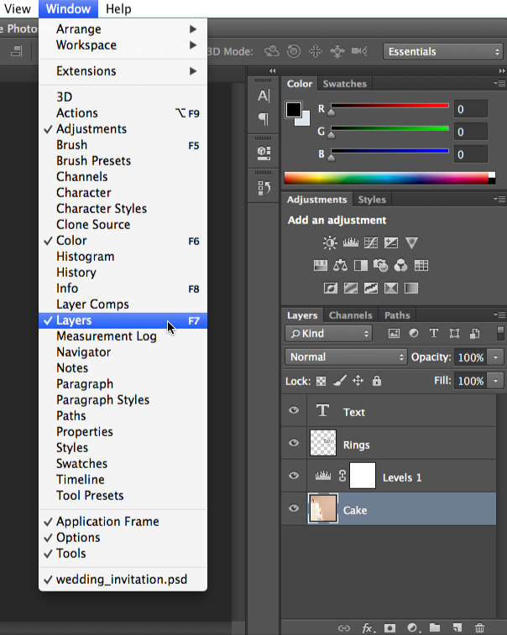

#### Creating an adjustment layer

If you've never used layers, we recommend trying adjustment layers first. Remember, an adjustment layer does not contain content; it simply allows you to apply adjustments to the layers below it.

1. In the **Layers** panel, select the layer below where you want the adjustment layer to appear. In our example, we'll select the **Cake** layer.
2. Click the **Adjustment** button at the bottom of the **Layers** panel, then choose the desired adjustment.

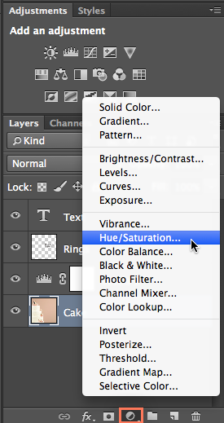

1. The adjustment layer will appear, and you can then customize the adjustment in the **Properties** panel. Any changes you make will affect every layer below the adjustment layer. We'll talk more about using the **Properties** panel for different adjustments throughout the tutorial.

You can also use the buttons in the **Adjustments** panel to create an adjustment layer.

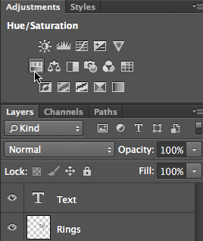

#### Try this!

In the example file, select the Cake layer, then create a **Hue/Saturation** adjustment layer. Try using the sliders in the **Properties** pane to see the effect.

#### Creating a blank layer

There may be times when you'll want to create a **new blank layer**. For example, if you want to draw on an image with the Brush tool, you could create a new layer and then draw on that layer.

To create a new layer, click the **New Layer** button near the lower-right corner of the **Layers** panel. The new layer will appear in the Layers panel.

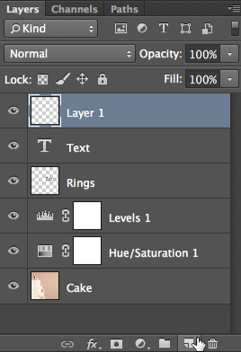

#### Duplicating a layer

There will also be times when you'll want to **duplicate** **an** **existing** **layer**. This is an easy way to try out different edits without altering the original layer.

1. Right-click the layer, then select **Duplicate Layer**...

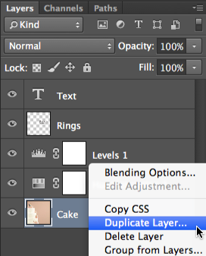

1. A dialog box will appear. Click **OK**. The duplicate layer will appear.

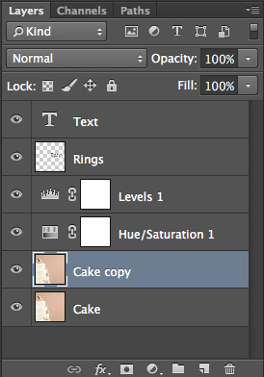

#### Deleting a layer

If you find that you no longer need a layer, you can **delete** **it**. To do this, simply select the layer and press the **Delete** key on your keyboard. You can also click and drag the layer to the **Trash Can** in the lower-right corner of the **Layers** panel.

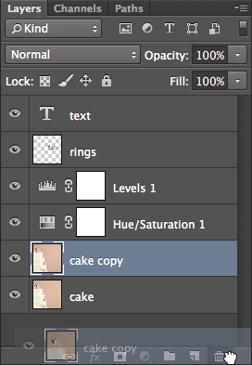

There are many ways to work with the layers in your file. For example, you can **show and hide** different layers or **change the stacking order**.

Showing and hiding layers

To hide a layer, simply click the **eye icon**next to the desired layer. Click it again to show the layer. In the image below, you can see that we've turned off the **Text** layer, so the text is no longer visible in the document window:

#### Reordering layers

The order in which layers are stacked will determine how the document looks. There may be times when you need to **change the stacking order**. To reorder a layer, simply click and drag the layer to the desired position in the **Layers** panel. In the image below, you can see that we've moved the **Cake** layer to the very top, which completely covers up the layers below it.

If you want to reorder the **Background layer** of the image, you will need to right-click it and select**Layer from Background**. This will convert the background to a regular layer, which can be reordered.

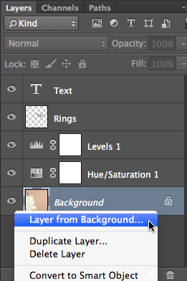

#### Try this!

Try **reordering** the layers to see the effect. Notice how moving the **Cake** layer to the very top will completely cover up the other layers, but moving the **Text** or **Rings** layer to the top does not.

#### Letting layers show through

In the example above, moving the **Cake** layer to the top completely covers up the layers below it. By contrast, moving the **Text** or **Rings** layer to the top would still allow parts of the layers below to show through. This is because these layers contain **transparent areas**, whereas the Cake layer does not.

What if we wanted the layers below the Cake layer to show through? There are many ways to do this, including changing the **opacity** of the layer and adding a **layer mask**. We'll cover these options in our lesson on [**doing more with layers**](https://edu.gcfglobal.org/en/photoshopbasics/doing-more-with-layers/1/).

#### Editing layers

The main advantage of layers is that you can **edit or adjust each layer individually** without affecting the rest of the file. As we mentioned earlier, there are several types of layers you can use, along with many **editing tools**. However, it's important to note that not all editing tools will work with all types of layers. This will become easier to understand as you gain more experience with Photoshop.

#### Using editing tools

You can use tools from the **Tools** panel and the **Filter** menu to edit layers. For example, you can use the **Move** tool to move different layers around in your file. In the image below, we're using it to move the **Rings** layer toward the bottom of the image.

#### Selecting layers before editing

For many types of edits, the desired layer must be selected **before** editing; otherwise, the wrong layer might be edited by mistake. If you use the **Eraser** tool, for example, it will only affect the layer you have selected. It's helpful to get into the habit of checking the Layers panel frequently to make sure you have the correct layer selected.

#### Editing text layers

If you want to edit a text layer, double-click the**layer** **icon** in the **Layers** panel. You can then change the text, choose a different font, or modify the text size and color.

#### Try this!

* In the example file, select the **Rings** layer, then use the **Move** tool to move the layer around the document.
* Double-click the layer icon for the **Text** layer, then try editing the text. For example, you could change the date from **June 21** to **June 15**.

While we've covered some fundamental information on layers, it's important to realize that there are many different ways to use them in Photoshop. We'll cover layers more throughout the tutorial, so you'll be able to build on the skills you've learned in this lesson.

#### Challenge!

If you'd like to follow along, you can download our [**example file**](https://media.gcflearnfree.org/ctassets/topics/247/save_the_date.psd).

1. **Open the example file** in Photoshop.
2. Try turning different layers **off** and **on** to see the effect.
3. Add a **Brightness/Contrast** adjustment layer, then use the sliders in the Properties panel to adjust the brightness and contrast.
4. Try **reordering** **layers** to see the effect.
5. Save the image as a **PSD file** to save your changes. This will preserve all of the layers so you can edit them again later if needed.
6. Use the **Save for Web** feature to export the image as a JPEG. Make sure to adjust the quality to find a balance between file size and image quality.
7. What are the steps of Image Slicing?

Ans: Here is an overview of how it works: when you have an image that will take too long to load on its own, you take advantage of the Slicing tool in Photoshop to cut the image into smaller sections. These images will be saved as a separate file and optimized using the Save for Web command.

In addition, Photoshop creates the HTML or CSS necessary to display the sliced image. When used in a web page, each image will be reassembled in the browser using the HTML or CSS mentioned earlier to create a smooth result. Here is an example of a sliced image.

**Slicing basics**

To keep things simple we will only work with the Slice tool on one layer. In this example I am working with an image which is 960x722px. Some things you need to know before we start:

* When creating slices, you can do using the Slice tool or you can build them using layers.
* Slices can be selected using the Slice Select tool.
* You can move, size, or align the slice with other slices. In addition you can designate a name for the slice, type and URL.
* Each slice can be optimized using the settings in the Save for Web dialog box.

To get started press **C** on your keyboard and click on the Slice tool.

When you create slices you can choose from three settings: Normal, Fixed Aspect Ratio, and Fixed Size.

* **Normal**: This will become a slice depending on where you begin and end the box you draw on the image.
* **Fixed Aspect Ratio**: This is where you set a height and width using whole numbers. To elaborate, if you want to create a slice with a three to one ratio, you would enter 3 for the height and 1 for the width.
* **Fixed Size**: This is where you set the height and width of the slice in pixels.

You have several options when slicing an image. If accuracy is not important, you can slice the image manually and if necessary, move the completed slices around using the Slice Select Tool.

If accuracy is important, use guidelines to map out the important sections in the image.

At the top of the Slicing menu bar, click on the C or the Slice tool to activate it and in the Slice menu bar above the image, click on the Slices from Guides button.

The slices are automatically drawn for you. You can then reposition the slices with the Slice Select Tool.

**Editing slice information**

After each Slice has been created, you can edit information about the slice in one of two ways.

The first thing to do is click on the Slice Select Tool, click on the slice you want to edit then click on the icon beside Show Auto Slices button in the menu bar.

Another option is to right-click on the slice and in the popup menu, click on Edit Slice Options.

Both choices will bring up the Slice Options dialog box.

As you can see, there are many settings. You can change the name of the slice, you can assign a URL to it so when it is clicked on in the browser it will take you to a different location, you can set the Target (_blank, _self, _parent, _top), Message Text, Alt Tag, Dimensions of the slice and more.

**Save for web**

Once you are satisfied with your layout, go to File>Save for Web.

Here, you can set the file type and compression for each slice or go with the default listed in the Save for Web dialog box. Once you are satisfied with your settings, click on the Save button.

This brings up the Saved Optimized As dialog box. At the bottom of the box are several important settings.

* **Format**: You have three options which are HTML and Images, Images Only, and HTML Only.
* **Settings**:Your options are Custom, Background Image, Default Settings, XHTML, and Other.
* **Slices**: Your options are All Slices, All User Slices, and Selected Slices.

For this tutorial I am using HTML and Images, Default Settings and All Slices. When you are satisfied with your settings, choose the folder where you want to save the files and click on the Save button. This creates an HTML file and saves all six images into a folder.

Here is a split screen view of the HTML file in Adobe Dreamweaver. As you can see, the code is straightforward and easy to use.

1. Define the term Artistic Filters, Distorting Filters.

Ans:Artistic filters emulate traditional art mediums using color, strokes, and textures resulting in creative painted-art images.

Distorting Filters move, stretch, and compress the pixels to create different effects. These often require higher computer memory to function.

1. Write down the steps to add text to a certain image with effects.
2. Ans: From the toolbar, select the Horizontal Type tool   or the Vertical Type tool  .
3. Do one of the following:

* + To create a single line of text, click in the image to set an insertion point for the type.
  + To create paragraph text, drag a rectangle to create a textbox for the type.

The small line through the I‑beam marks the position of the type baseline. For horizontal type, the baseline marks the line on which the type rests; for vertical type, the baseline marks the center axis of the type characters.

1. (Optional) Select type options, such as font, style, size, and color, in the tool options bar.
2. Type the characters you want. If you did not create a textbox, press Enter to create a new line.

The text appears in its own layer. To view the layers, in the Expert mode, press F11.

1. Commit the text layer by doing one of the following:

* + Click the Commit button .
  + Press the Enter key on the numeric keypad.
  + Click in the image, outside the textbox.
  + Select a different tool in the toolbox.

**Type tool options**

In the options bar, set the following Type tool options:

**Font Family**

Applies a font family to new or existing text.

**Font Style**

Applies font styles, such as bold, to new or existing text.

**Font Size**

Applies a font size to new or existing text.

**Color menu**

Applies a color to new text or selected text.

**Leading menu**

Sets the space between lines of new or selected text.

**Tracking**

Sets the space between the characters of new or selected text.

**Faux Bold**

Applies a bold style to new or existing text. Use this option if your font doesn’t have a true bold style that you can select from the Font Style menu.

**Faux Italic**

Applies an italic style to new or existing text. Use this option if your font doesn’t have a true italic or oblique style that you can select from the Font Style menu.

**Underline**

Applies an underline to new text or selected existing text.

**Strikethrough**

Applies a line through new text or selected existing text.

**Align Text**

Specifies text alignment. If text orientation is horizontal, lets you align text: left, center, or right. For vertical orientaion text: top, center, or bottom.

**Toggle Text Orientation**

Changes vertical text to horizontal and horizontal text to vertical.

**Warp text**

Warps text on the selected layer.

**Anti-aliased**

Applies anti-aliasing to make text appear smoother.

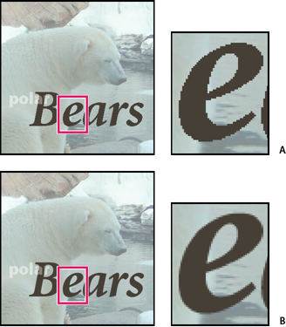

Applying anti-aliasing

**A.** Anti-aliasing off **B.** Anti-aliasing on

Use the Text on Shape tool

You can add text to the shapes available in the Text on Shape tool.

1. Select the Text on Shape tool . To quickly change the current text tool, press Option and click the current tool.

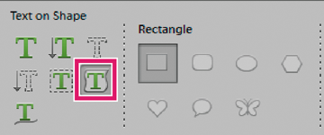

Text on Shape tool

1. From the available shapes, select the shape on which you want to add text. Drag the cursor on the image to create the shape.
2. To add text to the image, hover the mouse over the path until the cursor icon changes to depict text mode. Click the point to add text.

Modify text in the same way that you modify normal text.

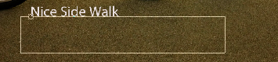

Click and enter text.

1. After adding text, click Commit . For some of the shapes the text has to be written inside. You can move the text around the path or by inside/outside by holding Cmd while clicking and dragging the mouse (The text appears in a small arrow). You can drag that cursor into a selected area, the text path is allowed inside/outside an area.

Use the Text on Selection tool

Add text on the outline of a path created from a selection. When you commit a selection, the selection is converted to a path on which you can type text.

1. Select the Text on Selection tool . To quickly change the current text tool, press Option and click the current tool.

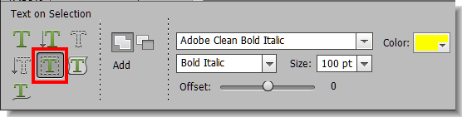

Text on Selection tool

2. Place the cursor on the object in the image and drag the cursor till you get your desired selection. You can adjust the size of your selection using the Offset slider.

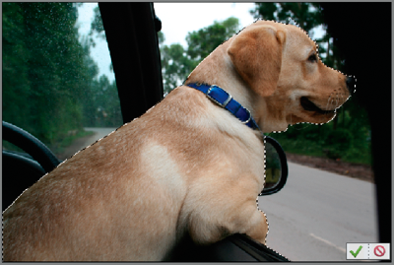

Make selection.

When you confirm the selection, the selection is converted to a path.

3. To add text to the image, hover the mouse over the path when cursor icon changes to depict text mode. Click the point to add text.

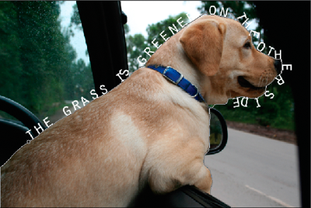

Add text.

After you add text, you can modify it like regular text.

4. After you have completed adding text, click the Commit . Cancel to start your workflow again.

Use the Text on Custom Path tool

You can draw and add text along the custom path.

1. Select the Text on Custom Path tool . To quickly change the current text tool, press Option and click the current tool.

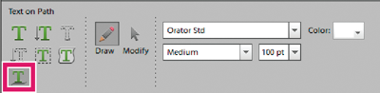

Text on Custom Path tool

1. Draw a custom path over the image. You can commit/cancel the drawn path to redraw from the tool options bar.
2. To refine or redraw the path, click Modify in the tool options bar. Use the nodes that appear on the path to modify it.
3. After you have completed creating a path, click the mouse at any point along the path to add text. Modify text in the same way that you modify normal text.

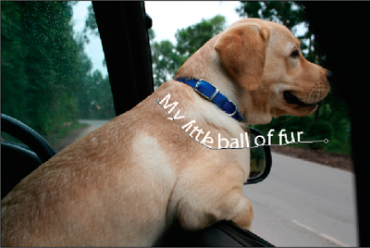

Add text.

1. After adding text, click the Commit .

Create and use masked type

The Horizontal Type Mask tool and Vertical Type Mask tool create a selection in the shape of text. You can have fun with text selection borders by cutting text out of an image to show the background, or pasting the selected text into a new image. Experiment with different options to personalize your images and compositions.

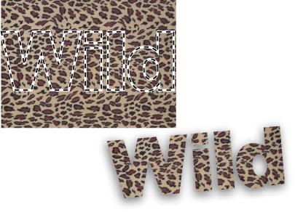

Horizontal type mask used to create a filled selection.

1. Using the Expert mode, select the layer on which you want the selection to appear. For best results, don’t create the type selection border on a text layer.
2. Select the Horizontal Type Mask tool   or the Vertical Type Mask tool  .
3. Select additional type options (See [Type tool options](https://helpx.adobe.com/photoshop-elements/using/add-text.html#type_tool_options)), and enter your text.
4. What are the steps of creating a basic animation in Photoshop? Write the step to restore an old image.

Ans: To create frame-based animations in Photoshop, use the following general workflow.

**Open a new document.**

If they are not already visible, open the Timeline, and Layers panels. Make sure the Timeline panel is in frame animation mode. In the middle of the Timeline panel, click the downpointing arrow to choose Create Frame Animation and then click the button next to the arrow.

**Add a layer or convert the background layer.**

Because a background layer cannot be animated, add a new layer or convert the background layer to a regular layer. See [Convert background and layers](https://helpx.adobe.com/photoshop/using/layer-basics.html#convert_background_and_layers).

**Add content to your animation.**

If your animation includes several objects that are animated independently, or if you want to change the color of an object or completely change the content in a frame, create the objects on separate layers.

**Add a frame to the Timeline panel.**

See [Add frames to an animation](https://helpx.adobe.com/photoshop/using/creating-frame-animations.html#add_frames_to_an_animation).

**Select a frame.**

See [Select animation frames](https://helpx.adobe.com/photoshop/using/creating-frame-animations.html#select_animation_frames).

**Edit the layers for the selected frame.**

Do any of the following:

* Turn visibility on and off for different layers.
* Change the position of objects or layers to make layer content move.
* Change layer opacity to make content fade in or out.
* Change the blending mode of layers.
* Add a style to layers.

Photoshop provides tools for keeping characteristics of a layer the same across frames. See [Unifying layer properties in animation frames](https://helpx.adobe.com/photoshop/using/creating-frame-animations.html#unifying_layer_properties_in_animation_frames).

**Add more frames and edit layers as needed.**

The number of frames you can create is limited only by the amount of system memory available to Photoshop.

You can generate new frames with intermediate changes between two existing frames in the panel using the Tween command. This is a quick way to make an object move across the screen or to fade in or out. See [Create frames using tweening](https://helpx.adobe.com/photoshop/using/creating-frame-animations.html#create_frames_using_tweening).

**Set frame delay and looping options.**

You can assign a delay time to each frame and specify looping so that the animation runs once, a certain number of times, or continuously. See [Specify a delay time in frame animations](https://helpx.adobe.com/photoshop/using/creating-frame-animations.html#specify_a_delay_time_in_frame_animations) and [Specify looping in frame animations](https://helpx.adobe.com/photoshop/using/creating-frame-animations.html#specify_looping_in_frame_animations).

**Preview the animation.**

Use the controls in the Timeline panel to play the animation as you create it. Then use the Save **For Web** command to preview the animation in your web browser.

**Optimize the animation for efficient download.**

See [Optimize animation frames](https://helpx.adobe.com/photoshop/using/saving-exporting-video-animations.html#optimize_animation_frames).

**Save the animation.**

There are different options for saving your frame animation:

* Save as an animated GIF using the Save For Web command.
* Save in Photoshop (PSD) format so you can do more work on the animation later.
* Save as an image sequence, QuickTime movie, or as separate files. See also [Export video files or image sequences](https://helpx.adobe.com/photoshop/using/saving-exporting-video-animations.html#export_video_files_or_image_sequences).

Add frames to an animation

Adding frames is the first step in creating an animation. If you have an image open, the Timeline panel displays the image as the first frame in a new animation. Each frame you add starts as a duplicate of the preceding frame. You then make changes to the frame using the Layers panel.

1. Make sure the Timeline panel is in frame animation mode.
2. Click the Duplicate Selected Frames button .

Select animation frames

Before you can work with a frame, you must select it as the current frame. The contents of the current frame appear in the document window.

In the Timeline panel, the current frame is indicated by a narrow border (inside the shaded selection highlight) around the frame thumbnail. Selected frames are indicated by a shaded highlight around the frame thumbnails.

**Select one animation frame**

1. Do one of the following in the Timeline panel:

* + Click a frame.
  + Click the Select Next Frame button  to select the next frame in the series as the current frame.
  + Click the Select Previous Frame button  to select the previous frame in the series as the current frame.
  + Click the Select First Frame button  to select the first frame in the series as the current frame.

**Select multiple animation frames**

1. In the Timeline panel, do one of the following:

* + To select contiguous multiple frames, Shift-click a second frame. The second frame and all frames between the first and second are added to the selection.
  + To select discontiguous multiple frames, Ctrl‑click (Windows) or Command-click (Mac OS) additional frames to add those frames to the selection.
  + To select all frames, choose**Select All** Frames from the panel menu.
  + To deselect a frame in a multiframe selection, Ctrl-click (Windows) or Command-click (Mac OS) that frame.

Edit animation frames

1. In the Timeline panel, select one or more frames.
2. Do any of the following:

* + To edit the content of objects in animation frames, use the Layers panel to modify the layers in the image that affect that frame.
  + To change the position of an object in an animation frame, select the layer containing the object in the Layers panel and drag it to a new position.

**Note:**

You can select and change the position of multiple frames. However, if you drag multiple discontiguous frames, the frames are placed contiguously in the new position.

* + To reverse the order of animation frames, choose Reverse Frames from the panel menu.

**Note:**

The frames you want to reverse do not have to be contiguous; you can reverse any selected frames.

* + To delete selected frames, choose Delete Frame from the Timeline panel menu or click the Delete icon , then click Yes to confirm the deletion. You can also drag the selected frame onto the Delete icon.

Unify layer properties in animation frames

The unify buttons (Unify Layer Position, Unify Layer Visibility, and Unify Layer Style) in the Layers panel determine how the changes you make to attributes in the active animation frame apply to the other frames in the same layer. When a unify button is selected, that attribute is changed in all the frames in the active layer; when that button is deselected, changes apply to only the active frame.

The Propagate Frame 1 option in the Layers panel also determines how the changes you make to attributes in the first frame will apply to the other frames in the same layer. When it is selected, you can change an attribute in the first frame, and all subsequent frames in the active layer will change in relation to the first frame (and preserve the animation you have already created).

**Unify layer properties**

1. In the Timeline panel, change the attribute to one frame.
2. In the Layers panel, click Unify Layer Position  , Unify Layer Visibility  , or Unify Layer Style   to have the changed attribute apply to all other frames in the active layer.

**Propagate Frame 1**

1. In the Layers panel, select the Propagate Frame 1 option.
2. In the Timeline panel, change the attribute for the first frame.

The changed attribute is applied (in relation) to all subsequent frames in a layer.

**Note:**

You can also propagate frames by Shift-selecting any consecutive group of frames in the layer and changing an attribute in any of the selected frames.

**Show or hide unify layers buttons**

1. Choose Animation Options from the Layers panel menu, and then choose one of the following:

**Automatic**

Displays the unify layers buttons when the Timeline panel is open.

**Always Show**

Displays the unify layers buttons whether the Timeline panel is open or closed.

**Always Hide**

Hides the unify layers buttons whether the Timeline panel is open or closed.

Copy frames with layer properties

To understand what happens when you copy and paste a frame, think of a frame as a duplicate version of an image with a given layer configuration. When you copy a frame, you copy the configurations of layers (including each layer's visibility setting, position, and other properties). When you paste a frame, you apply that layer configuration to the destination frame.

1. Select one or more frames you want to copy in the Timeline panel.
2. Choose Copy Frame(s) from the panel menu.
3. Select a destination frame or frames in the current animation or another animation.
4. Choose Paste Frame(s) from the panel menu.
5. Select a Paste method:

**Replace Frames**

Replaces the selected frames with the copied frames. No new layers are added. The properties of each existing layer in the destination frames are replaced by those of each copied layer. When you paste frames between images, new layers are added to the image; however, only the pasted layers are visible in the destination frames (the existing layers are hidden).

**Paste Over Selection**

Adds the contents of the pasted frames as new layers in the image. When you paste frames into the same image, using this option doubles the number of layers in the image. In the destination frames, the newly pasted layers are visible, and the original layers are hidden. In the non-destination frames, the newly pasted layers are hidden.

**Paste Before Selection or Paste After Selection**

Adds the copied frames before or after the destination frame. When you paste frames between images, new layers are added to the image; however, only the pasted layers are visible in the new frames (the existing layers are hidden).

1. (Optional) To link pasted layers in the Layers panel, select Link Added Layers.

This option works only when pasting frames into another document. Select it when you plan to reposition the pasted layers as a unit.

1. Click OK.

Create frames using tweening

The term *tweening* is derived from "in betweening," the traditional animation term used to describe this process. Tweening (also called *interpolating*) significantly reduces the time required to create animation effects such as fading in or fading out, or moving an element across a frame. You can edit tweened frames individually after you create them.

You use the Tween command to automatically add or modify a series of frames between two existing frames—varying the layer properties (position, opacity, or effect parameters) evenly between the new frames to create the appearance of movement. For example, if you want to fade out a layer, set the opacity of the layer in the starting frame to 100%; then set the opacity of the same layer in the ending frame to 0%. When you tween between the two frames, the opacity of the layer is reduced evenly across the new frames.

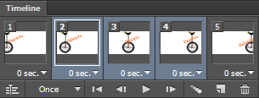

Using tweening to animate text position

1. To apply tweening to a specific layer, select it in the Layers panel.
2. Select a single frame or multiple contiguous frames.

* + If you select a single frame, you choose whether to tween the frame with the previous frame or the next frame.
  + If you select two contiguous frames, new frames are added between the frames.
  + If you select more than two frames, existing frames between the first and last selected frames are altered by the tweening operation.
  + If you select the first and last frames in an animation, these frames are treated as contiguous, and tweened frames are added after the last frame. (This tweening method is useful when the animation is set to loop multiple times.)

1. Do one of the following:

* + Click the Tweens button  in the Timeline panel.
  + Choose Tween from the panel menu.

1. Specify the layer or layers to be varied in the added frames:

**All Layers**

Varies all layers in the selected frame or frames.

**Selected Layer**

Varies only the currently selected layer in the selected frame or frames.

1. Specify layer properties to be varied:

**Position**

Varies the position of the layer's content in the new frames evenly between the beginning and ending frames.

**Opacity**

Varies the opacity of the new frames evenly between the beginning and ending frames.

**Effects**

Varies the parameter settings of layer effects evenly between the beginning and ending frames.

1. If you selected a single frame in step 2, choose where to add frames from the Tween With menu:

**Next Frame**

Adds frames between the selected frame and the following frame. This option is not available when you select the last frame in the Timeline panel.

**First Frame**

Adds frames between the last frame and first frame. This option is available only if you select the last frame in the Timeline panel.

**Previous Frame**

Adds frames between the selected frame and the preceding frame. This option is not available when you select the first frame in the Timeline panel.

**Last Frame**

Adds frames between the first frame and last frame. This option is available only if you select the first frame in the Timeline panel.

1. In the Frames To Add box, enter a value, or use the Up or Down Arrow key to choose the number of frames. (This option is not available if you selected more than two frames.)
2. Click OK.

Add a new layer for each new frame

The Create New Layer For Each New Frame command automatically adds a new layer visible in the new frame but hidden in other frames. This option saves time when you are creating an animation that requires you to add a new visual element to each frame.

1. Choose Create New Layer For Each New Frame from the Timeline panel menu.

A check mark indicates that the option is turned on.

Hide layers in animation frames

When you create a new layer, it is visible in all animation frames by default.

* To show new layers only in active frames, deselect New Layers Visible In All Frames from the Timeline panel menu.
* To hide a layer in a specific frame, select the frame, and then hide the desired layer in the Layers panel.

Specify a delay time in frame animations

You can specify a *delay*—the time that a frame is displayed—for single frames or for multiple frames in an animation. Delay time is displayed in seconds. Fractions of a second are displayed as decimal values. For example, one-quarter of a second is specified as .25. If you set a delay on the current frame, every frame you create after that will remember and apply that delay value.

1. Select one or more frames in the Timeline panel.
2. Click the Delay value below the selected frame to view the pop‑up menu.
3. Specify the delay:

* + Choose a value from the pop‑up menu. (The last value used appears at the bottom of the menu.)
  + Choose Other, enter a value in the Set Frame Delay dialog box, and click OK. If you selected multiple frames, specifying a delay value for one frame applies the value to all frames.

Choose a frame disposal method

The frame disposal method specifies whether to discard the current frame before displaying the next frame. You select a disposal method for animations that include background transparency to specify whether the current frame will be visible through the transparent areas of the next frame.

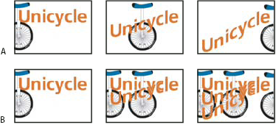

Frame disposal methods

**A.** Frame with background transparency with Restore To Background option **B.** Frame with background transparency with Do Not Dispose option

The Disposal Method icon indicates whether the frame is set to Do Not Dispose  or Dispose . (No icon appears when Disposal Method is set to Automatic.)

1. Select a frame or frames for which you want to choose a disposal method.
2. Right-click (Windows) or Control-click (Mac OS) the frame thumbnail to view the Disposal Method context menu.
3. Choose a disposal method:

**Automatic**

Determines a disposal method for the current frame automatically, discarding the current frame if the next frame contains layer transparency. For most animations, the Automatic option (default) yields the desired results.

**Note:**

*To preserve frames that include transparency, select the Automatic disposal option when you are using the Redundant Pixel Removal optimization option.*

**Do Not Dispose**

Preserves the current frame as the next frame is added to the display. The current frame (and preceding frames) may show through transparent areas of the next frame. Use a browser to see an accurate preview of an animation using the Do Not Dispose option.

**Dispose**

Discards the current frame from the display before the next frame is displayed. Only a single frame is displayed at any time (and the current frame does not appear through the transparent areas of the next frame).

Specify looping in frame animations

You select a looping option to specify how many times the animation sequence repeats when played.

1. Click the Looping Option Selection box at the lower-left corner of the Timeline panel.
2. Select a looping option: Once, 3 Times, Forever, or Other.
3. If you selected Other, enter a value in the Set Loop Count dialog box, and click OK.

**Note:**

Looping options can also be set in the Save for Web dialog box.

1. Why is Eyedropper tool used? What are different types of transformation used in Photoshop?

Ans: Eyedropper tool can sample colors from anywhere in an image and add them to your swatches panel.

How to Transform an Object

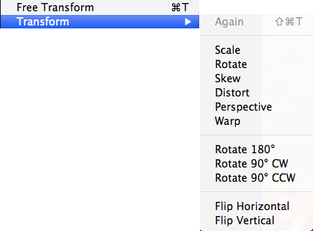

Many objects, shapes, or images that we create are not always the ideal size, roation, or skew that we want. We can alter or transform objects by using the ***Transform*** and ***Free Transform Tools***.

**Transform**

The ***Transform***feature allows users to alter their object or selection in a variety of ways, such as scale, rotate, distort, or flip (mirror).

* To use the ***Transform*** feature, select a layer or create a new selections.
* Got to *Edit* in the menu, select ***Transform***, and select the type of transformation you wish to make.
* A bounding box will appear around your selection and allow you to transform it using the handles. If you use Roate 180°, Rotate 90°, Flip Horizontal, or Flip Vertical then your image will automatically be transformed.

**Free Transform**

The ***Free Transform***feature allows you to make several transformations at once, rather than one at a time.

* To use the ***Free Transform*** feature, select a layer or create a new selections.
* Got to Edit in the menu, select ***Free Transform.*** A bounding box will appear around your selection.
* You can now transform the selection using the bounding box handles.  
  + Scale - Grab corner handles and adjust size
  + Rotate - Move cursor slightly away from corner handle, moving it away from the selection. The cursor will turn into a curved double arrow and allow you to rotate the selection.
  + Distort - Place your cursor over a handle, hold down the CTRL (Windows) or COMMAND (Mac) key so that the cursor becomes white, and grab a handle to distort.
  + Skew - Place your cursor over a handle, hold down the CTRL (Windows) or COMMAND (Mac) + SHIFT keys so that the cursor becomes white, and grab a handle to skew.
  + Perspective - Place your cursor over a handle, hold down the CTRL (Windows) or COMMAND (Mac) + ALT + SHIFT keys so that the cursor becomes white, and grab a handle to change perspective.

|  |
| --- |
| http://lgimages.s3.amazonaws.com/data/imagemanager/7565/composite.jpg  *Using the transform features to add depth to an image.* |

9.What is the use of histogram? How can you change a gray scale image into color image?

Ans: A histogram divides up to an range of possible values in a data set into classes or groups. For each group , a rectangular is constructed with a base length equal to the range of values in that specific group and a length equal to the number of observations falling into that group.

The first way to get out of Grayscale Mode in Photoshop is to convert your document from Grayscale to RGB or CMYK. The Photoshop RGB Color Mode uses three color channels (Red, Green, Blue) to display all the colors in your project.RGB color is the most common mode used and is the default mode for Photoshop. However, if this was changed to Grayscale, you can easily return to the RGB mode by clicking **Image > Mode > RGB Color.**

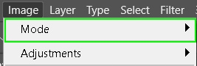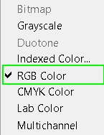

Another common color mode used with images in Photoshop is the CMYK mode. This mode deals with the four-color CMYK printing process, therefore giving you more accurate colors, relative to printing. This process is when Cyan, Magenta, Yellow, and Black inks are mixed together to produce over 16,000 color combinations. If you’re going to print an image, it’s advised that you convert it to the CMYK color space before printing.

In this case, you can convert your image to the CMYK mode by clicking**Image > Mode > CMYK Color**.

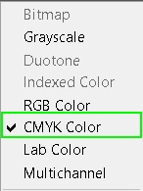

**Option 2: Set Your New Document To RGB or CMYK**

Another way to escape the clutches of Grayscale is to create your new document in the RGB or CMYK Color Mode. This is only useful, however, if you do not have an existing project that is facing this problem.

Since this method only works for new projects, be sure to use the previous method for any existing project stuck in Grayscale!

Click **File > New** and in the popup window, look at the **Color Mode section**. If it’s set to Grayscale, click it, and from the dropdown menu, select **RGB** or **CMYK** to create your new document in either of those color modes.

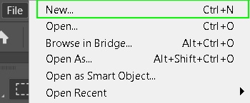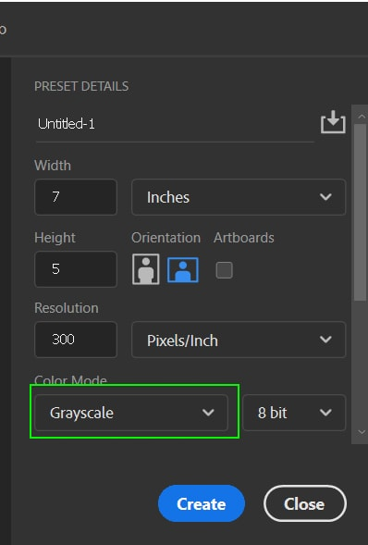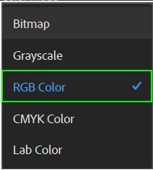

1. Design an identity card of yourself.

